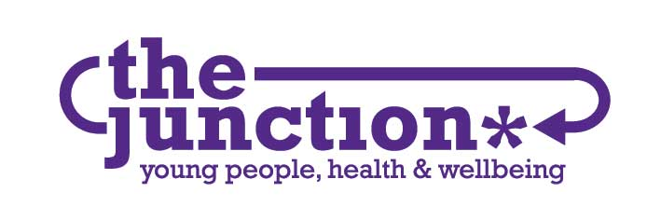

JOB DESCRIPTION

POST Project Worker – Young Person’s Voice

BASE The Junction, 82 – 86 Great Junction Street, Leith, EH6 5LL

HOURS 35 hours per week (until 31st March 2021)
Flexible including evenings and weekends

MANAGEMENT Responsible to Senior Project Worker
Accountable to Board of Trustees via the Service Manager

RATE OF PAY £25,820

PURPOSE OF JOB

This is a new role, supported by The Listening Fund to support us to build on how we listen to young people’s voices to enable us further embed the role we do. The role also includes delivering services for young people within The Junction’s Nested Provision Model.

- To take lead role in supporting our Junction Youth Advisors and other young people’s voices at The Junction while identifying, exploring and delivering new possibilities for young people’s involvement.

- To provide one-to-one support to young people.

- To play a role in the provision of a high quality health and wellbeing Open Access services for young people.

REPORTING RELATIONSHIPS

The post-holder will work as part of The Junction’s staff team. They will report to The Junction Board of Trustees and funders via Service Manager or Director.

KEY TASKS AND RESPONSIBILITIES:

- To work within the parameters of The Junction’s agreed polices. Promoting the ethos and objectives of the organisation and the services it runs.

- Being the lead worker in implementing The Junction’s Listening Fund application to The Corra Foundation. Providing a specialist role in listening to young people.

- To play a lead role in supporting and enhancing the capacity of the young volunteers - The Junction Youth Advisors

- Working alongside the Junction Director and young people in influencing systemic change and sharing our nested provision model

- Engaging with young people; preparing, facilitating and evaluating activities; dealing with queries; offering informal support, sign posting on and providing access to The Junction’s other services where appropriate.

- To prepare, facilitate and evaluate agreed one to one programmes for up to 4 young people per week.

- To be available at a minimum of one Open Access session per week. To respond appropriately and flexibly to young people’s emotional wellbeing, sexual health and physical wellbeing needs as part of the Open Access service.

- Contributing to the collection of relevant data and the development and operation of monitoring and evaluation systems.

- To work in partnership with colleagues towards the development of a peer based approach.

- Using a broad range of approaches to develop innovative work involving young people as much as possible in the designing and planning of activities.

- Networking, forming relationships and outreach work with key partners.

- Prepare for and attend regular support/supervision meetings with the Senior Project Worker and attend appropriate training as identified, negotiated with the Senior Project Worker.

- To attend staff meetings and training.

- To provide mentoring/support to volunteers and students working within the organisation as required.

- To respond to any concerns regarding neglect or abuse in a sensitive and appropriate manner

- To contribute to Organisational development and good practice

- To undertake other tasks, assigned by the Senior Project Worker, which reasonably fall within the scope of the post.

SUPERVISION

- The post holder will prepare for and participate in support and supervision with the Senior Project Worker and will report directly to them.

- The post holder will prepare for participate in clinical supervision with the Senior Counsellor.

PERSONAL SPECIFICATION
CRITERIA | ESSENTIAL | DESIRABLE
QUALIFICATIONS | - Relevant professional qualification e.g. Community Education, Social Work, Health Promotion, Nursing or equivalent | - Any training/qualifications relevant to working with young people
EXPERIENCE | - Worked directly with young people around specific issues  - Experience of collaborating with other agencies and working in a range of settings  - Facilitating young people’s participation | - Health Issues work with young people  - Sexual Health work with young people  - Involvement in awareness raising campaigns  - Experience in providing high quality training material and resources  - Experience working within a peer based model
KNOWLEDGE AND SKILLS | - Comprehensive understanding of issues affecting young people  - One-to-one work  - Group work  - Excellent verbal and written communication skills  - Ability to innovate and use a range of approaches  - An understanding of the principles of monitoring and evaluation  - Ability Managing own workload and prioritise  - An understanding of local and national strategies | - Delivery of training  - Presentation skills  - Research skills  - Use of Microsoft office packages
PERSONAL QUALITIES | - Enthusiastic and highly motivated  - Effective communicator with people of all ages and backgrounds  - Committed and open to challenge  - Flexible, dynamic, innovative and resourceful  - Ability to work on own initiative and as part of a team  - Reflective practitioner
OTHER | - Must be available two evenings a week – one must be a Thursday | - A clean driving license

