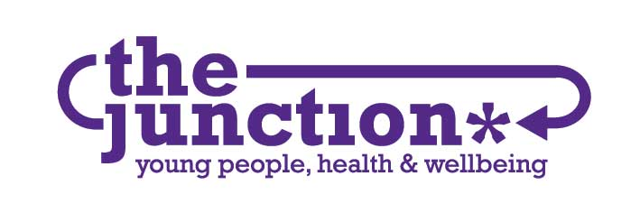

POST Young Person’s Counsellor
Maternity Cover – Ends 31st Dec 2020

BASE Initially Home Working and then
The Junction, 82-86 Great Junction Street, Edinburgh

HOURS 21 Hours per week, Flexible including evenings &
weekends

MANAGEMENT Responsible to Service Manager.
Accountable to Board of Trustees

SALARY Starting salary £28,706, pro rata: £17,223

PURPOSE OF JOB

To provide trauma informed counselling for up to 20 sessions with young people aged 12-21 accessing The Junctions nested provision model. The post holder will have an understanding of the differing stages of development and needs of young people.

A key focus of this role will be supporting young people in response to the trauma and impact of Coronavirus. Initially, this will be remote support, but as the situation evolves, the role will be delivering face to face assessment and counselling work.

The post holder will liaise with schools and other statutory and non-statutory agencies when required and contribute to the evaluation and monitoring of the service.

The role holder will also be expected to embrace and contribute to a peer based working model within the organisation.

REPORTING RELATIONSHIPS

The post-holder will work as part of the Junction staff team. They will report to The Junction Board of Trustees & funders via the Service Manager.

KEY TASK AREAS:

- To work within the parameters of “The Junction’s” agreed polices. Promoting the ethos and objectives of the organisation and the services it runs.

- To assess young people’s psychological / emotional needs and deliver appropriate counselling or referral as required

- To provide counselling for young people aged 12-21, providing phone support and face to face work – maintain a case load of 6-8 young people

- To demonstrate a high standard of knowledge about the needs of young people and to work well in tandem with them responding to their voiced or perceived needs

- When appropriate to work in partnership with other members of the organisation.

- Using a broad range of approaches to offer an integrative experience involving young people as much as appropriate in the designing, planning and evaluation of their service.

- Networking, forming relationships and outreach work with youth work agencies, schools and other key partners.

- Contributing to the collection of relevant data and the development and operation of monitoring and evaluation systems.

- To contribute to staff groups of relevant agencies in order to promote the service and explain its ethos and working methods

PROFESSIONAL RESPONSIBILITIES

- To promote and respect client confidentiality at all times within the parameters of child protection

- To respond to any concerns regarding neglect or abuse in a sensitive and appropriate manner adhering to Junction policy

- To have knowledge of relevant child protection guidelines.

- To attend staff meetings and training as negotiable within hours.

- When appropriate to refer young people to agencies best placed to meet their needs

- Contribute to planning and organising the delivery of training to other professionals
- To maintain client records in accordance with BACP and Junction guidelines

SUPERVISION

- Management support and supervision with the Service Manager, one hour monthly

- Clinical supervision with the Senior Counsellor, fortnightly.

PERSON SPECIFICATION FOR POST OF: Young Person’s Counsellor (maternity post)

CRITERIA | ESSENTIAL | DESIRABLE
QUALIFICATIONS | - Formal Counselling qualification to diploma level or above | - Relevant professional qualification e.g. Community Education, Social Work, Health Promotion, Nursing or Teaching  - Evidence of ongoing professional development  - Group work qualification  - Certificate in Supervision  Phone and Remote Counselling Training
EXPERIENCE | - Experience of counselling work with young people  - Experience of assessing the mental health needs of young people | - Experience in providing high quality training material & resources  - Experience of operating monitoring & evaluation systems  - Previous experience of working with schools.  - Experience working within a peer based model  - Experience of providing phone counselling
KNOWLEDGE & SKILLS | - Sound understanding of issues affecting young people  - Awareness of inequalities  Excellent verbal & written communication skills  - Ability to innovate & use a range of approaches  - Knowledge of referral  agencies | - Delivery of training  - Experience of Group Work  - Presentation skills  - Research skills  - IT  - An understanding of the principles of monitoring & evaluation  - An understanding of local  & national strategies, including GIRFEC
PERSONAL QUALITIES | - Enthusiastic & well motivated  - Effective communicator with people of all ages & backgrounds  - Committed & open to challenge  - Flexible, Dynamic, Innovative & resourceful  - Ability to work using own initiative  - & as part of a team
OTHER | - Member of BACP &/or COSCA  - Available to work irregular hours, evenings & weekends | Accredited member of BACP or COSCA,  or actively working towards this.

