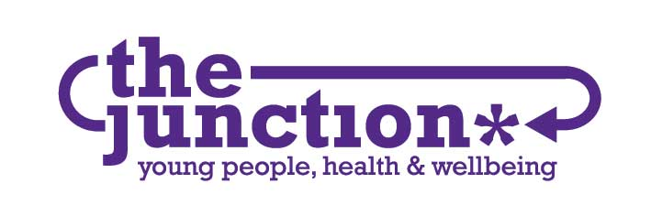

JOB DESCRIPTION

POST Project Manager
BASE 82-86 Great Junction Street, Edinburgh, EH6 5LL,
Home Based During Current Restrictions
HOURS 28 hours per week
CONTRACT Fixed Term for 12 months
MANAGEMENT Line managed by the Service Manager
RATE OF PAY £30,000 per annum full time (£24,000 pro rata)

PURPOSE OF JOB

Project Management:
- Have overall responsibility for the delivery of all Junction projects and youth participation services (open access services, e.g. drop in, outreach).
- Support proposal writing and tender submissions, including engagement with potential funders.
- Support participative strategies for The Junction to engage and support young people to be involved in the project process and co design approach.
- Overseeing The Junction's youth participation work, including supporting others to engage with young people and to develop and facilitate project work.

People Management:
- To manage, support and advise a team of Project Workers to fully deliver on their key objectives and deliverables.
- Promoting the ethos and objectives of the organisation in a peer-based working environment.
Operations:
- Oversee the development and implementation of The Junction operational plan.
- Oversee the monitoring, review and evaluation of the ongoing effectiveness of the project work carried out by The Junction.
- To work within the parameters of The Junction’s agreed polices.
- The post holder will be The Junction’s Child Protection and Safeguarding Officer.

Relationships:
- Take the lead on networking, forming relationships with youth work agencies, designated schools and other key partner and stakeholders.
- Maintain relationships with project partners and funders.
- Engage with young people and encourage their involvement in identifying key areas for service development.
- Be a member of the leadership team supporting the Service Manager and the Office Manager.

REPORTING RELATIONSHIPS

This position will report to the Service Manager.

The post-holder will have the following line management responsibilities:

- Creative Express Project Worker.
- Substance Use Project Worker.
- Young Person’s Voice Project Worker.
- Positive Pathways Project Worker (x2)

PERSON SPECIFICATION: Project Manager

CRITERIA | ESSENTIAL | DESIRABLE
EXPERIENCE | Relevant professional qualification e.g. Community Education, Social Work, Health Promotion.  Or relevant experience in one of the above disciplines.  Experience of supervising and managing others.  Experience of child protection and safeguarding. | Any training/qualifications relevant to working with young people.  Experience of working in a Public Social Partnership organisation  Project Management Qualification.
KNOWLEDGE  and SKILLS | Ability to manage and mentor a team.  Comprehensive understanding of issues affecting young people.  Experience of one-to-one working with young people.  Excellent verbal and written communication skills.  Ability to innovate and use a range of approaches.  Ability to monitor and evaluate projects successfully. | Health Issues work with young people  Sexual Health work with young people  Involvement in awareness raising campaigns  Experience in providing high quality training material and resources  Awareness of a peer based working environment.
PERSONAL QUALITIES | An enthusiastic motivator of others.  Effective communicator with people of all ages and backgrounds.  Commitment to the aims and values of the Junction in particular equal opportunities, diversity and inclusion.  An individual who works well under pressure with the ability to work on own initiative and as part of a team.  Computer literate with experience of IT and Office 365.  Flexible, dynamic, innovative and resourceful to meet the needs of the Junction.  Creating a culture of mutual respect and open to learning from others and sharing knowledge as appropriate.  Non-judgemental, approachable and reliable.  Actively adopts a growth mindset and takes responsibility for personal development. | Facilitation, presentation and research skills  An understanding of local and national strategies relating to young people
OTHER | Available to work irregular hours, evenings and weekends as required.  To be available at a minimum of one Open Access session per week to provide ad hoc one-to-one sessions for vulnerable young people  To undertake other tasks, assigned by the Service Manager, which reasonably fall within the scope of the post

